Case 5-Asia-Thailand-Ban Chiang-Bangles-Bronze-3600 BCE
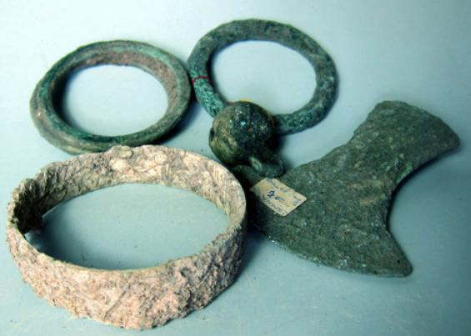
Fig. 1. Thailand-Ban Chiang-Bangles-Bronze-3600 BCE
Case no.:
Accession Number:
Formal Label: Thailand-Ban Chiang-Bangles-Bronze-3600 BCE
Figs. 1-3. Ban Chiang-Bowl-Pedestal Stemcup-Ceramic-Red on Buff-300 BCE-300 CE
Case no.:
Accession Number:
Formal Label: Ban Chiang-Bowl-Pedestal Stemcup-Ceramic-Red on Buff-300 BCE-300 CE
Display Description: These Ban Chiang bronze bangles may date to the earliest grave 2000 BCE, as evidenced by crucibles and bronze fragments.[5] Bronze objects include bracelets, rings, anklets, wires and rods, spearheads, axes and adzes, hooks, blades, and little bells.
LC Classification: DS589.B17
Date or Time Horizon: 300 BCE-300 CE
Geographical Area: Ban Chiang, Udon Thani, Thailand
Map:
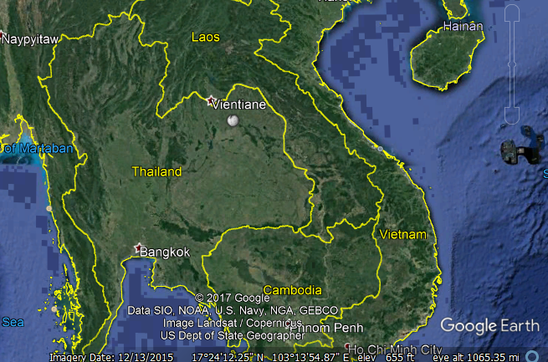
Fig. 4. Ban Chiang is near Vientiane
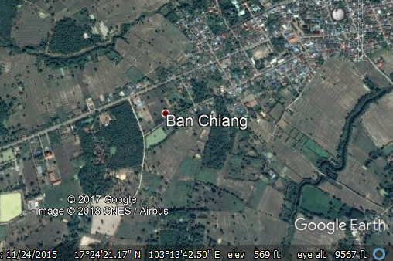
Fig. 6. Detail of Ban Chiang location
GPS coordinates: 17°24′25″N 103°14′29″E
Cultural Affiliation: Ban Chiang
Medium: Clay
Dimensions: 14 cm at widest and 14.5 cm high
Weight: 660 gm
Condition: original
Provenance: Thailand
Discussion:
A date of 2100 BCE was obtained from rice phytoliths from inside a grave vessel of the lowest grave. A dating program for this site has involved dating the bones from the people who lived at Ban Chiang and the bones of animals interred with them. The resulting determinations have been analysed using the Bayesian statistic OxCal 4.0, and the results suggested that the initial settlement of Ban Chiang took place by about 1500 BCE, with the transition to the Bronze Age about 1000 BCE.
References:

Higham, Charles. 1998. Prehistoric Thailand. River Books; 1st Edition edition.
Higham C.F.W. and T.F.G. Higham 2009. “A new chronological framework for prehistoric Southeast Asia, based on a Bayesian model from Ban Non Wat,” Antiquity 82:1-20.

Higham C.F.W. 2011. The Bronze Age of Southeast Asia: new insight on social change from Ban Non Wat. Cambridge Archaeological Journal 21(3): 365-89

Higham C.F.W., R. Ciarla, T.F.G. Higham, A. Kijngam and F. Rispoli. 2011. “The establishment of the Bronze Age in Southeast Asia,” Journal of World Prehistory 24 (4),227-274:

Higham C.F.W., T.F.G. Higham and A. Kijngam. 2011. “Cutting a Gordian Knot: The Bronze Age of Southeast Asia, timing, origins and impact,” Antiquity 85:583-98.

Pietrusewsky, Michael; Douglas, Michele T. (Michele Toomay) 2001. "Intensification of Agriculture at Ban Chiang: Is There Evidence from the Skeletons?" (PDF). Asian Perspectives. Project MUSE: University of Hawai'i Press. 40 (2): 157–178. doi:10.1353/asi.2001.0023. eISSN 1535-8283. ISSN 0066-8435..

White, J.C. and Hamilton, E. G. 2009. “The Transmission of Early Bronze Technology to Thailand: New Perspectives,” World Prehistory 22: 357–397

White, J.C. 2008 “Dating Early Bronze at Ban Chiang, Thailand.” In From Homo erectus to the Living Traditions. Pautreau, J.-P.; Coupey, A.-S.; Zeitoun, V.; Rambault, E., editors. European Association of Southeast Asian Archaeologists, Chiang Mai, pp. 91-104.

White, J. C. 1995. “Incorporating Heterarchy into Theory on Socio‐political Development: The Case from Southeast Asia,” Archeological Papers of the American Anthropological Association, 6(1), 101-123.

